**Daniel Tilley – C1437041 – Design Document**

The dataset for this assignment is based on Airplane crashes. In oracle, the tables are laid out as follows:

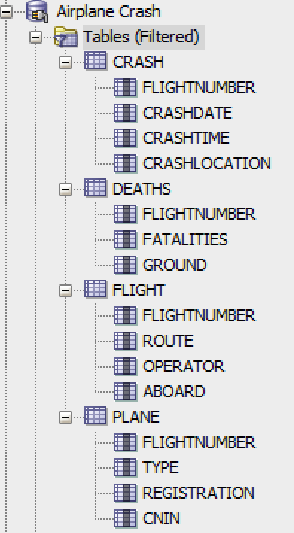

**Designs**

There are 2 design options I am going to implement. The first is just a straight data dump with no formatting and the second will make use of embedding.

***Simple Design:***

db.createCollection(simpleFormat, {

FlightNumber: <number>,

FlightRoute: <string>,

FlightOperator: <string>,

NumAboardFlight: <number>,

CrashDate: <string>,

CrashTime: <string>,

CrashLocation: <string>,

DeathsInAir: <number>,

DeathsOnGround: <number>,

PlaneType: <string>,

PlaneReg: <string>,

PlaneCNIN: <string>} )

***Embedded Design: (Uses flight as a first reference)***

db.createCollection(embeddedFormat, {

Number: <number>,

Route: <string>,

Operator: <string>,

NumAboard: <number>,

Plane: [{

Type: <string>,

PlaneReg: <string>,

PlaneCNIN: <string>

}],

Crash: [{

Date: <string>,

Time: <string>,

Location: <string>,

Deaths: [{

InAir: <number>,

OnGround: <number>

}],

}]

} )

**Creates**

I have attached two files which have been generated using PL/Sql. One is for the simple layout (simpleLayoutOutput.txt) and the other is for the embedded layout (embeddedLayoutOutput.txt). In both files, you will find the PL/Sql used to generate the file and the creates for mongoDB.

**Queries on simple collection**

***Find all***

db.simpleFormat.find()

***Find certain airline***

db.simpleFormat.find({ FlightOperator: "Air France" })

***Sort by amount of deaths in air***

db.simpleFormat.find().sort( { DeathsInAir: -1 } )

***Aggregate function. Sum number of deaths in air and filter by airline***

db.simpleFormat.aggregate([

{ $match: { FlightOperator: "Air France" }},

{ $group: { _id: "$ObjectId", DeathsInAir: { $sum: "$DeathsInAir" } } },

])

***Update function***

db.simpleFormat.update({“FlightNumber”: 1},{$set:{“DeathsInAir”: 2}} )

**Queries on embedded collection**

***Find all***

db.embeddedFormat.find()

***Find certain airline***

db.embeddedFormat.find({ Operator: "Military - U.S. Air Force" })

***Sort by amount of deaths on ground***

db.embeddedFormat.find().sort( { "Crash.Deaths.OnGround": -1 } )

***Aggregate function. Sum number crashes by airline***

db.embeddedFormat.aggregate([

{ $match: { Operator: "Military - U.S. Air Force" }},

{ $unwind: '$Crash'},

{ $group: { _id: "$ObjectId", count: { $sum: 1 } } },

])